**Assignment 1**

**1Q,**

**Ans:** The three stages of reproducible work flow are:

1. Data Collection
2. Data Processing and
3. Data Analysis

1.Data Collection:

* In this stage we will convert the excel file into csv file since csv files are convenient for data processing.
* In the next step we need to store this data and make the folder structure accordingly.

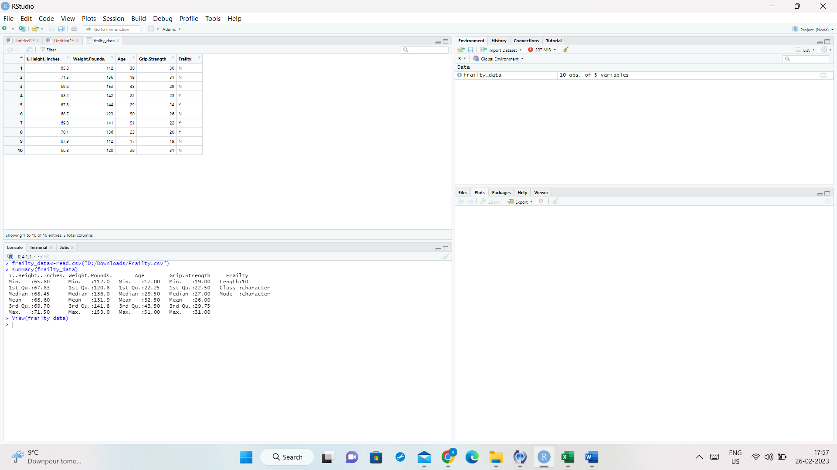

2. Data processing

* It involves data cleaning and checking if there are any null values in the frailty column.

**clean_data <- na.omit(frality_data[frality_data$Frailty != 'NA', ])**

* After performing all the necessary activities, we are saving the cleaned data into a new csv file.

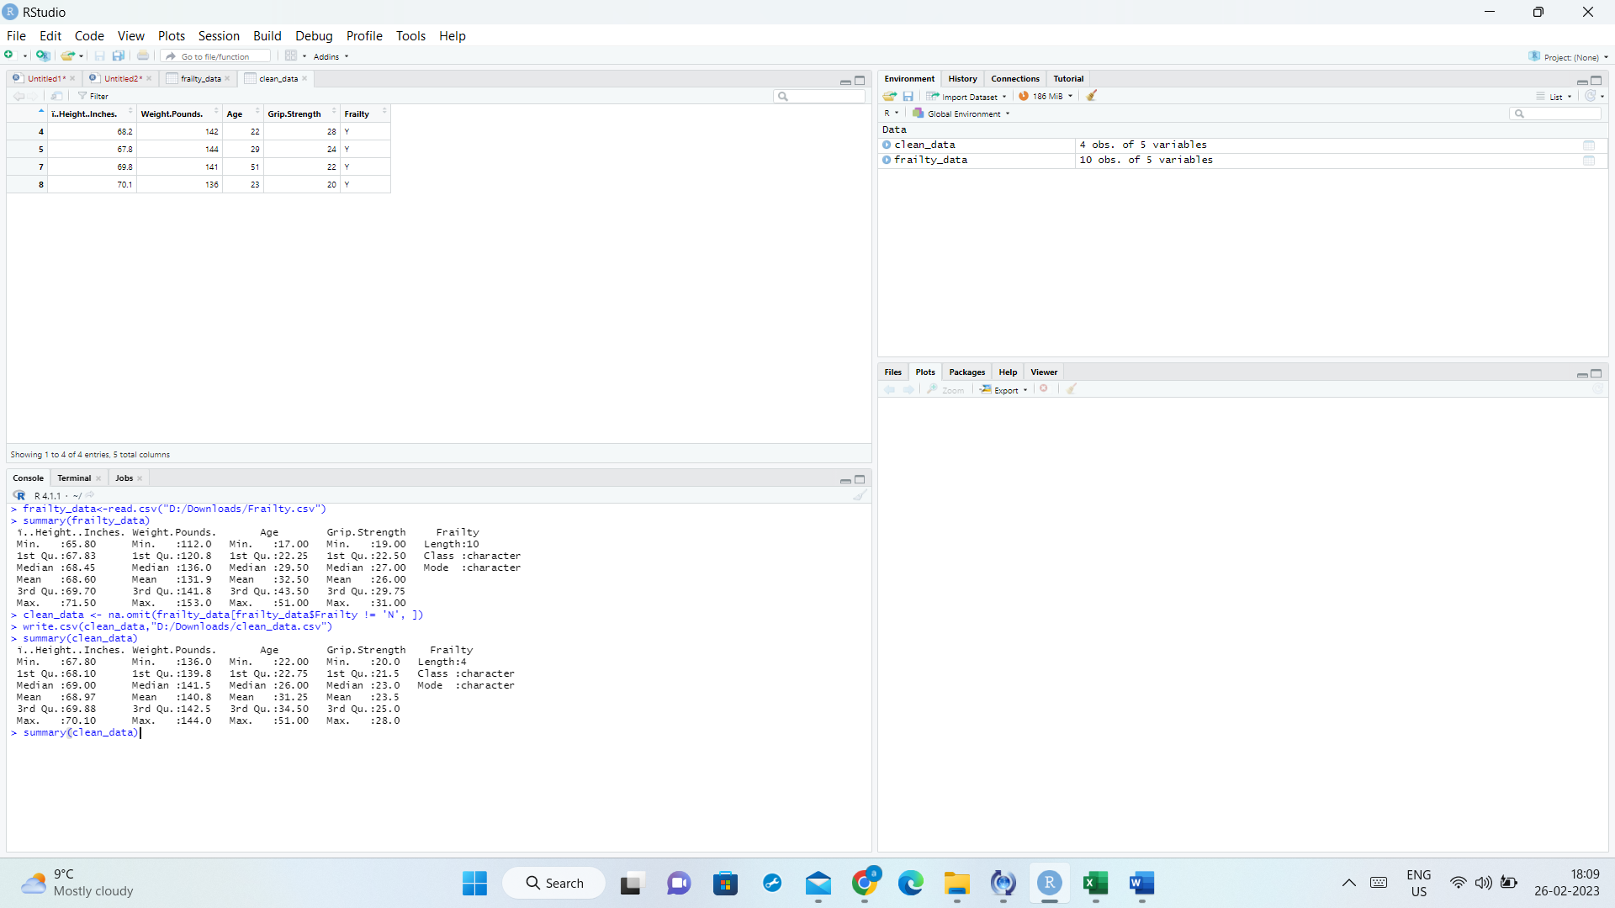

Stage 3: Data Analysis

* In this step we will be reading clean data into a new variable(clean_data).

**clean_data <- na.omit(frailty_data[frailty_data$Frailty != 'N', ])**

* Perform T Test analysis on clean_data field wise to see if there is a significant difference in Age and Grip

**test_frailty<-t.test(clean_data$Age, clean_data$Grip, paired = TRUE)**

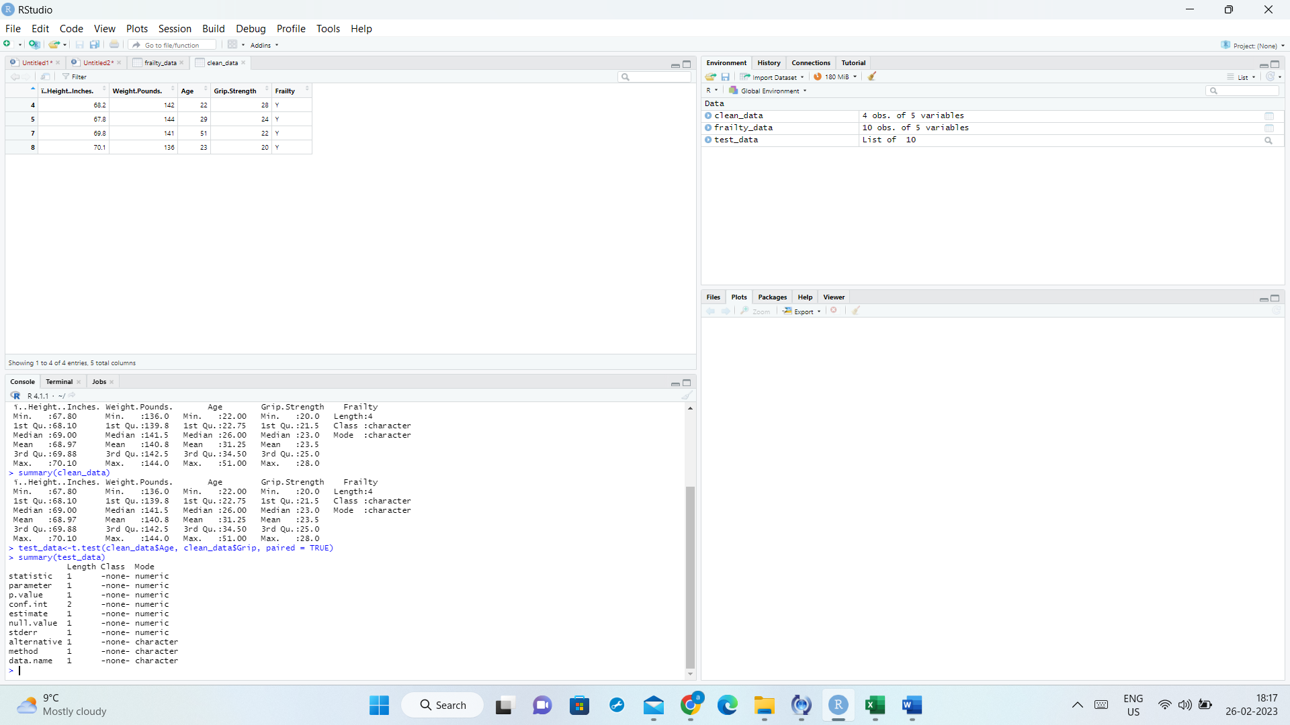

* Saving the output to a text file

**capture.output(test_data, file = "D:/Downloads/output.txt")**

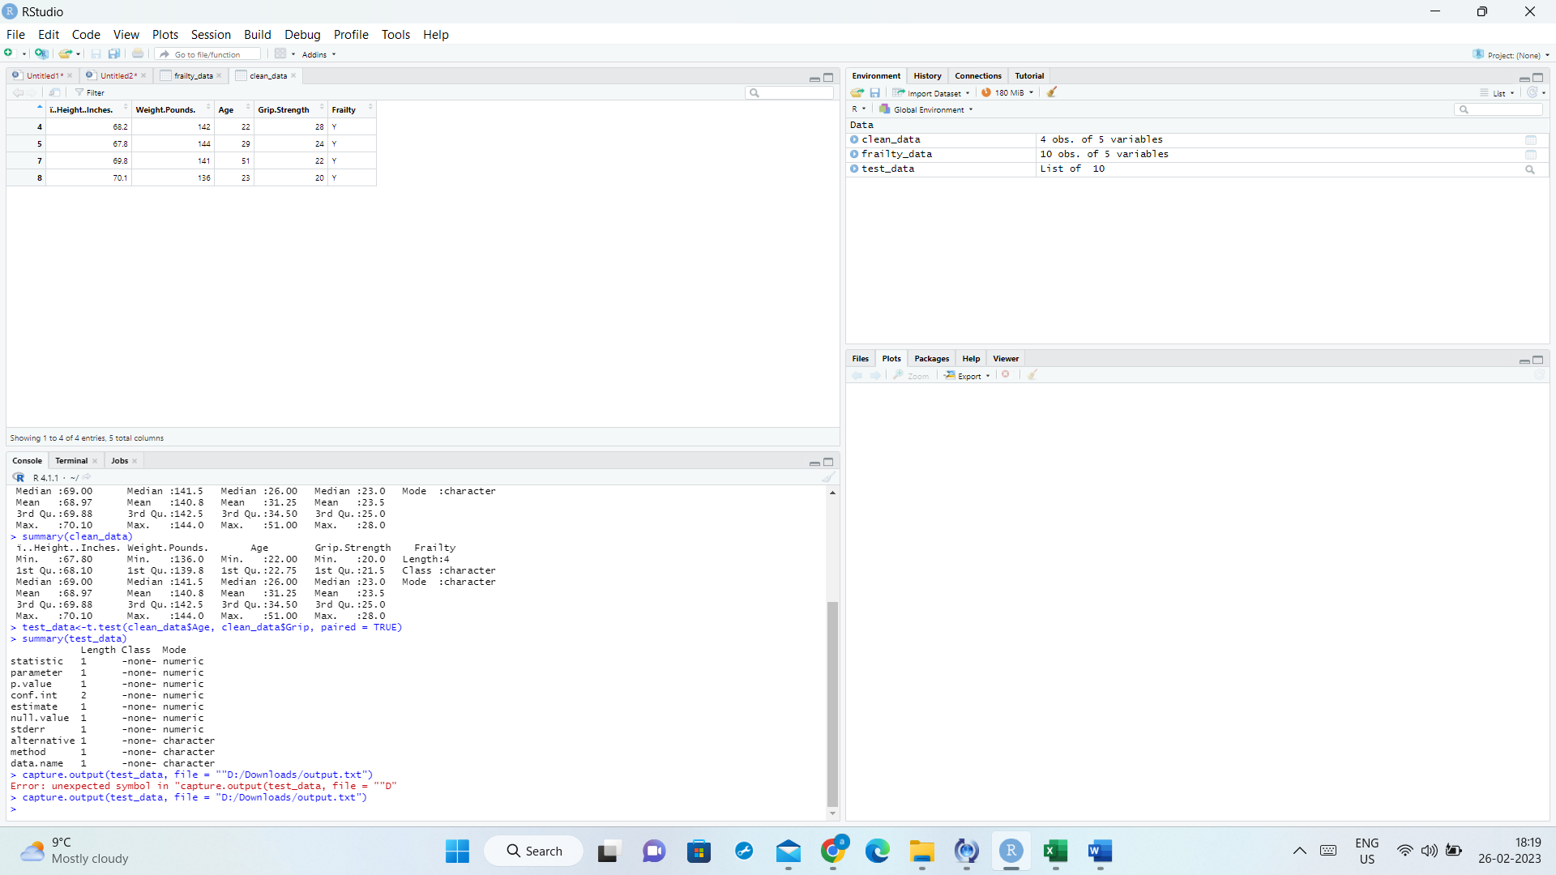

**Plotting the Age vs Grip data:**

